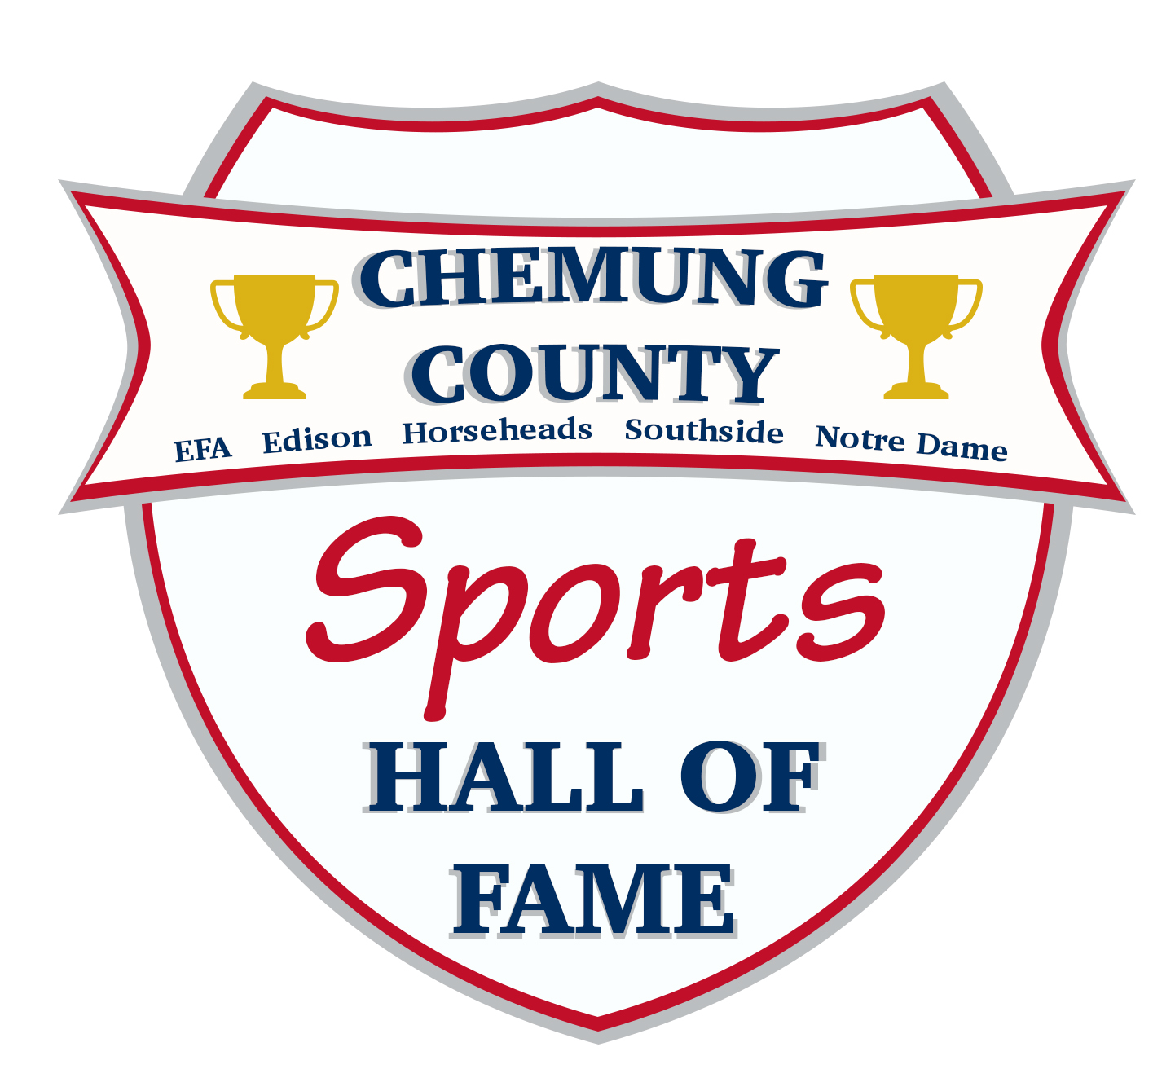
EFA • EDISON • ELMIRA HS• HORSEHEADS • SOUTHSIDE • NOTRE DAME

ATHLETE NOMINATION FORM

Criteria:
- Athletes must be in their own High School Hall of Fame to be considered for Chemung County Sports of Hall of Fame
- Athletes can be nominated after 5 years of graduating from High School

Date Submitted:
To the best of my knowledge, the above information is correct:
Last Name: First: Maiden:
Street: City: State:
Zip Code: County:
Home Phone: Work Phone: Cell Phone:
E-Mail: School Attended:
Years in High School: Year Graduated:

EMPHASIS IS ON HIGH SCHOOL ACHIEVEMENTS ONLY
Varsity Sports No. of Years Years Completed
___________ ___________ ______________
___________ ___________ ______________
___________ ___________ ______________
___________ ___________ ______________

Special Recognition (League All Star-All State-All American, etc.)
Sport Classification Year
________________ ___________ _______________
________________ ___________ _______________
________________ ___________ _______________
________________ ___________ _______________

Established Records (League, Sectional, State, National, etc.)
Classification Sport Year Record
___________ _______________ _______ ____________
___________ _______________ _______ ____________
___________ _______________ _______ ____________

Comments on Individual Records:

Primary emphasis is on High School Achievements
(Such as football-TD’s; basketball scoring, rebounds; baseball hitting average, pitching, etc.)

Other pertinent information:

Achievements Beyond High School: (i.e. College, Prep School, Professional, Career, etc.)

IF NO RECORDS ARE AVAILABLE, PLEASE TRY TO BE AS ACCURATE AS POSSIBLE.
Please return this application by OCTOBER 1 to the address below OR e-mail to reidmediagroup@gmail.com

Chemung County Sports Hall of Fame
3300 Chambers Road South
Suite 5242
Horseheads, NY 14845

